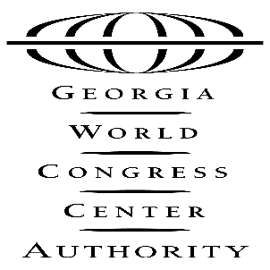
PRELIMINARY AGENDA

GWCCA PERSONNEL COMMITTEE MEETING

Tuesday, July 30, 2019
11:00 AM
Administration Conference Room

I. Welcome
II. February 26, 2019, Meeting Minutes (ACTION ITEM)
III. Fiscal Year-End Performance Update
IV. Authority Business
- Executive Session – Organizational Performance (Action Item)
V. Adjourn

285 ANDREW YOUNG INTERNATIONAL BOULEVARD, N.W. ATLANTA, GA 30313.1591 404.223.4000 FAX 404.223.4011
www.gwcc.com

