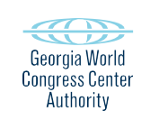
PRELIMINARY AGENDA
GWCCA EXECUTIVE COMMITTEE
Tuesday, June 28, 2022
GWCCA Sales Northside Conference Room (Bldg. C)
11:00 a.m.

I. Call to Order and Welcome

II. Approval of Minutes – May 24, 2022 (ACTION ITEM)

III. Authority Business

- Hotel Update

- Capital Improvements Update – Roofing

- Ballroom Chair RFP

- Path Foundation Trail Hub License Agreement 2022

- Adjourn

